INSTALLATION OF WORDPRESS

Step 1 : DOWNLOAD XAMPP

* Goto google and search xampp

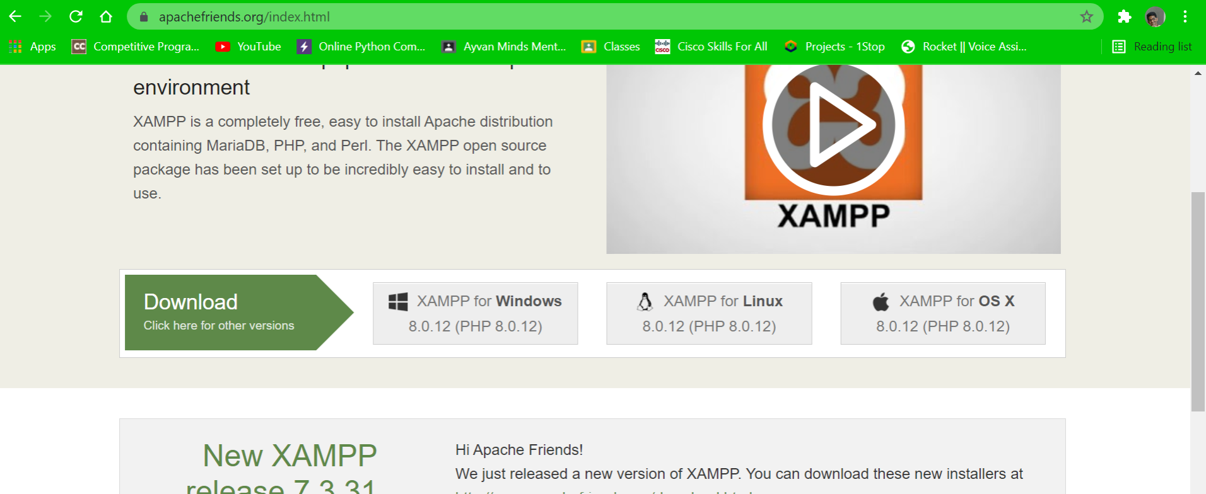

* Download according to the system os
* After downloading launch the xampp to install

Step 2 : DOWNLOAD WORDPRESS

* Goto google and search for wordpress

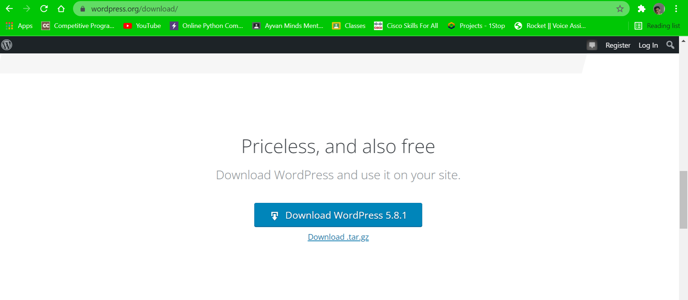

Step 3: Turn on Apache and Mysql

* Goto the searchbar and search for xampp
* By clicking on that we can access the xampp controlpanel
* Turn on Apache and mysql servers.

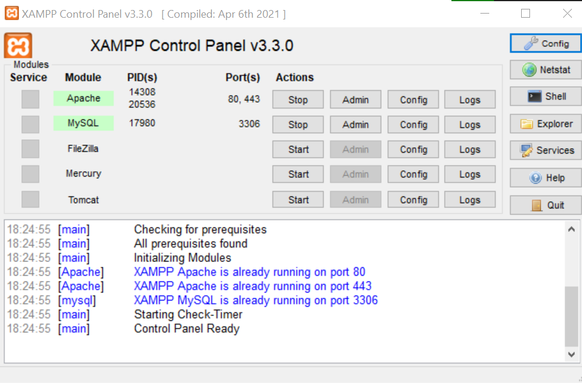

Step-4: MOVING WORDPRESS TO xampp

* Copy the downloaded file of wordpress
* Open xampp folder in c drive
* Then go to htdocs and paste the copied file
* Then rightclick and click on extract here
* Then there will be a folder called wordpress in htdocs

Step-5 : CREATE A DATABASE

* Goto google and type <http://localhost/phpmyadmin/>
* Click on database and type in a name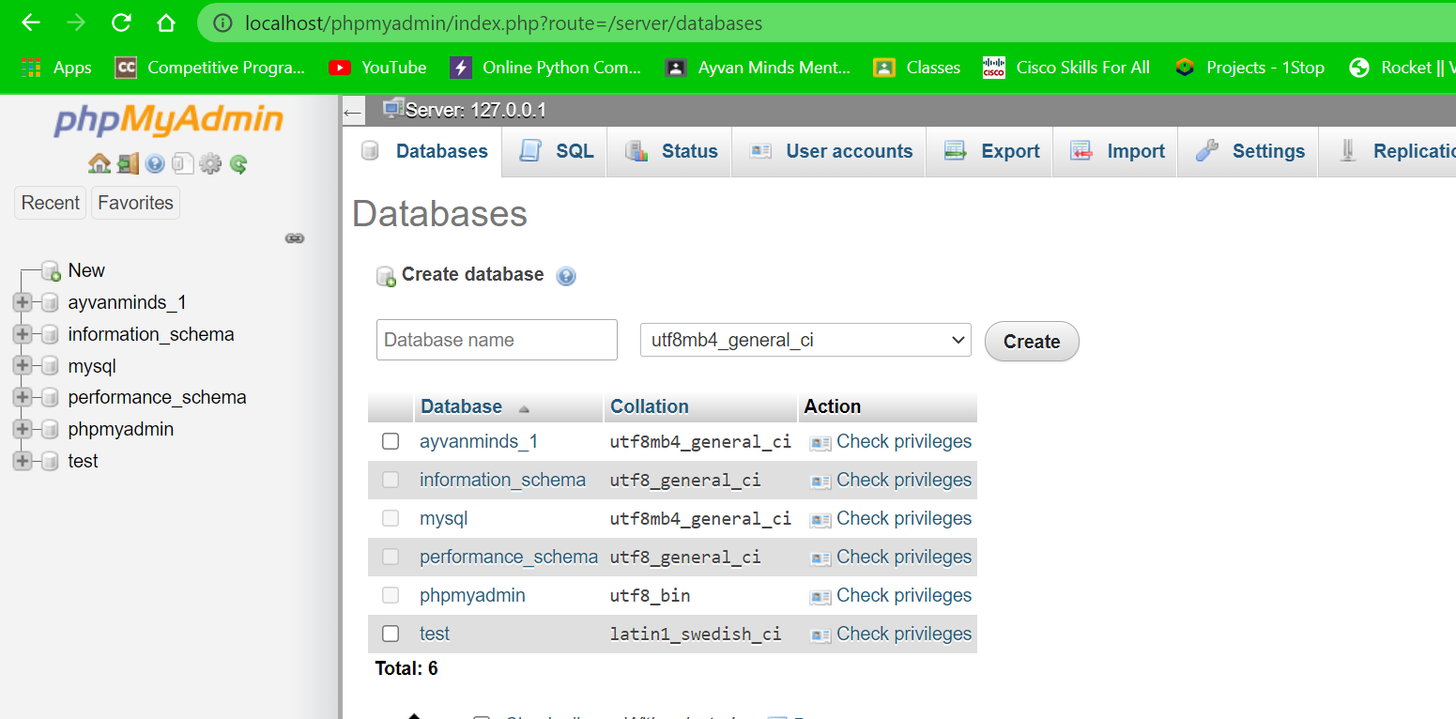

Step – 6 : CONNECT DATABASE TO WORDPRESS

* Now goto google and enter <http://localhost/ayvan%20minds/>
* Here I renamed wordpress with ayvan minds
* 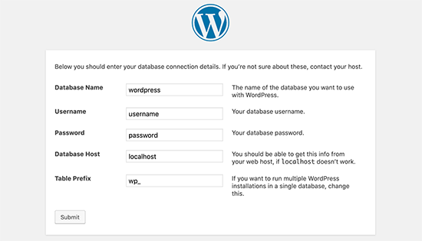
* Here enter the created data base name
* Enter username as root and leave blank for password
* After clicking on submit it will be redirected to another page where it asks for installation of wordpress.
* Click on it

Step -7 : LOGGING INTO WORDPRESS

* Goto google and enter <http://localhost/ayvan%20minds/wp-login.php>?

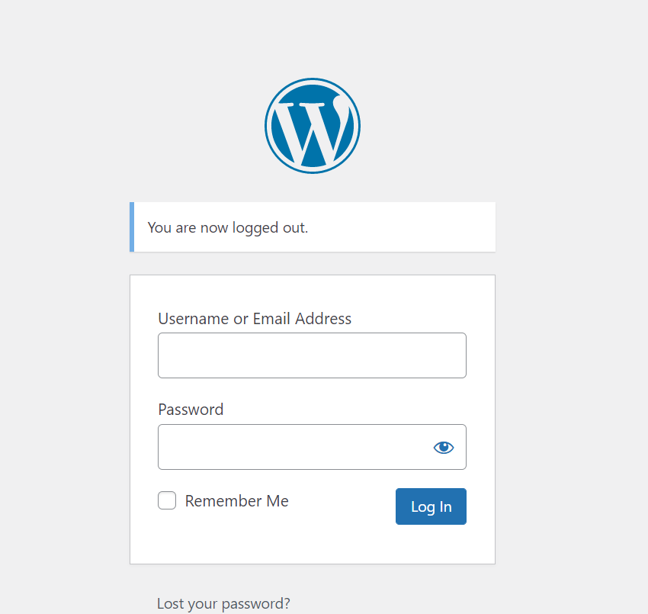

* Fill in the username and password you created.
* After that it will be redirected to the dashboard. 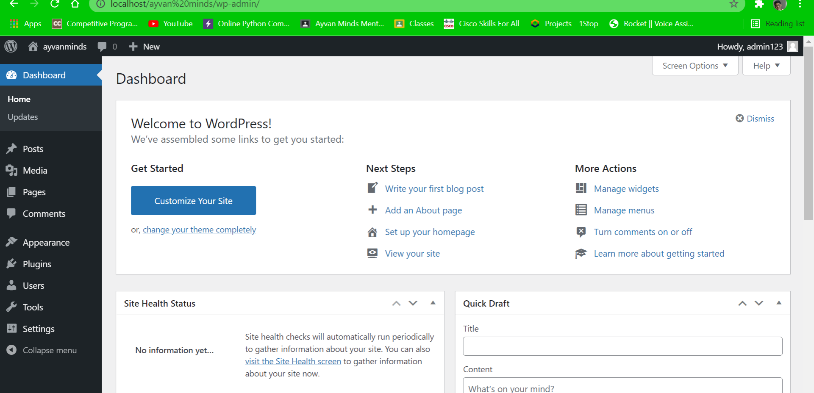

Step – 8:

* Goto google and enter <http://localhost/ayvan%20minds/>
* Your site will be opened.

